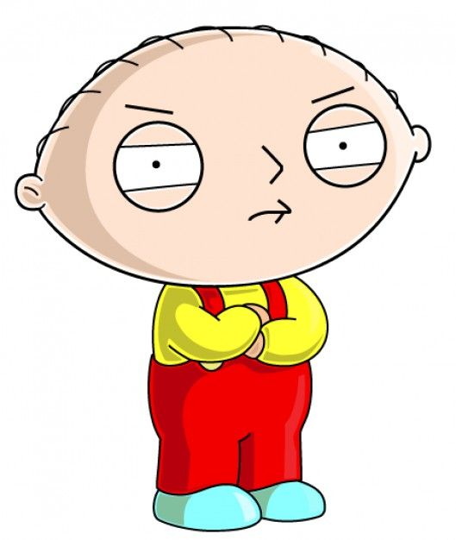

He is short. He has got big eyes and head. He has got small ears. He is bald. He is rude and angry.

– His name is Stewie Griffin



He is not tall. He has got big eyes. He is bald. He is overweight. He is merry and funny.

– His name is Homer Simpson

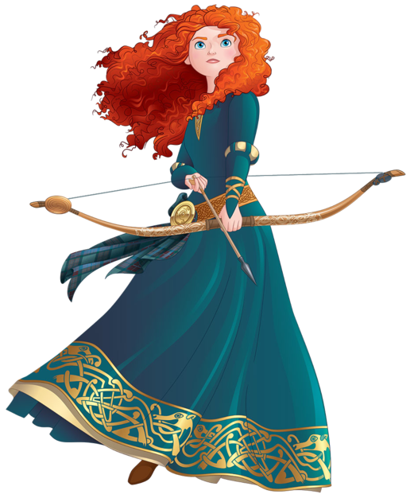

She is tall and slim. She has got long curly ginger hair and big blue eyes. She is brave and serious.

- Her name is Merida

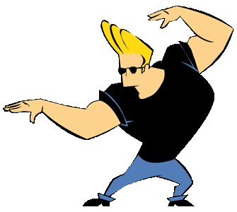

He is tall and fit. He has got short fair hair. He is strong and brave.

- His name is Johnny Bravo

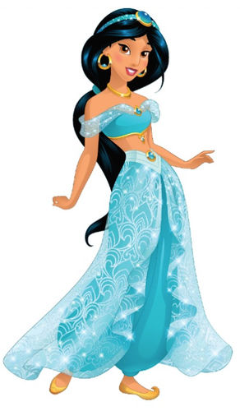

She is not tall. She is slim. She has got long straight black hair and brown eyes. She is beautiful and kind.

Her name is Jasmine

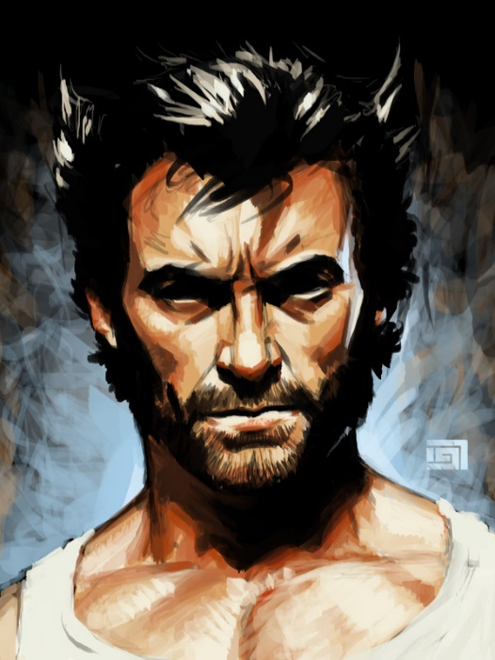

He is not tall. He has got short black hair and black eyes. He has got a beard and moustache. He is fit and strong.

His name is Wolverine



She is thin and tall. She has got long wavy brown hair and brown eyes. She has got glasses. She is pessimistic and moody but smart.

- Her name is Daria Morgendorffer